GFIT Framework Key Performance Indicators

# Version history

|  |  |  |
| --- | --- | --- |
| Date | Author | Change Log |
| 28/9/2017 | Edward Moore | Initial Draft |

Contents

Version history 2

Introduction 6

Basics 7

Milestone Requirement analysis complete 7

GFIT Planning - Missing Test Coverage 7

KPI Type 7

Entities Measured: 7

Fields required 7

GFIT Planning - Functional Coverage 7

KPI Type 7

Entities Measured: 7

Fields required 7

GFIT Planning – Non-Functional Coverage 8

KPI Type 8

Entities Measured: 8

Fields required 8

Milestone System Test Planning Complete 8

GFIT Planning - Missing Test Coverage 8

KPI Type 8

Entities Measured: 8

Fields required 8

GFIT Planning – Tests Marked Ready 8

KPI Type 8

Entities Measured 8

Required Fields 8

Milestone Unit Test Planning Complete 8

GFIT Planning - Missing Test Coverage 8

KPI Type 9

Entities Measured: 9

Fields required 9

GFIT Planning – Tests Marked Ready 9

KPI Type 9

Entities Measured 9

Required Fields 9

Milestone UAT Test Planning Complete 9

GFIT Planning - Missing Test Coverage 9

KPI Type 9

Entities Measured: 9

Fields required 9

GFIT Planning – Tests Marked Ready 9

KPI Type 9

Entities Measured 9

Required Fields 10

Milestone Unit Test Execution Complete 10

KPI Optional Configuration 10

GFIT Control – Priority 1 test cases executed 11

KPI type 11

Entities Measured 11

Fields required 11

GFIT Control – Priority 2 test cases executed 11

KPI type 11

Entities Measured 11

Fields required 11

GFIT Control – Other test cases executed 11

KPI type 11

Entities Measured 11

Fields required 11

GFIT Control – Passed Tests 12

KPI type 12

Entities Measured 12

Fields required 12

Milestone System Test Execution Complete 12

GFIT Control – Priority 1 test cases executed 12

KPI type 12

Entities Measured 12

Fields required 12

GFIT Control – Priority 2 test cases executed 12

KPI type 12

Entities Measured 12

Fields required 12

GFIT Control – Other test cases executed 12

KPI type 13

Entities Measured 13

Fields required 13

GFIT Control – Passed Tests 13

KPI type 13

Entities Measured 13

Fields required 13

Milestone UAT Execution Complete 13

GFIT Control – Priority 1 test cases executed 13

KPI type 13

Entities Measured 13

Fields required 13

GFIT Control – Priority 2 test cases executed 13

KPI type 13

Entities Measured 14

Fields required 14

GFIT Control – Other test cases executed 14

KPI type 14

Entities Measured 14

Fields required 14

GFIT Control – Passed Tests 14

KPI type 14

Entities Measured 14

Fields required 14

Milestone Code is defect free 15

GFIT Control – Critical Defects 15

KPI Type 15

Entities Measured 15

Required Fields 15

GFIT Control – Major Defects 15

KPI Type 15

Entities Measured 15

Required Fields 15

GFIT Control – Average Defects 15

KPI Type 15

Entities Measured 15

Required Fields 15

ALM Screens this information comes from 16

# Introduction

This document explains in detail how each of the Key performance indicators are configured in the GFIT Test Framework. It will also serve as a guide to the use of Key Performance indicators overall in HP ALM.

# Basics

Key performance indicators are applied to Milestones. Nothing else, just milestones.

The GFIT Test Framework template waterfall release with cycles has nine milestones covering three test phases. This is intentional to keep it as simple as possible.

1. Requirement analysis complete
2. Unit test planning complete
3. System test planning complete
4. Unit test execution complete
5. System test execution complete
6. UAT planning complete
7. UAT execution complete
8. Overall progress
9. Code is defect free

# Milestone Requirement analysis complete

There are three Key Performance indicators covering the milestone “Requirement Analysis Complete”

Please note that as of 28/9/2017 the coverage Key Performance Indicators are slightly unstable. You may see an error message about missing type “6”. I cannot resolve this without access to the ALM administration site. This needs to be resolved by [MTS@NORDEA.COM](mailto:MTS@NORDEA.COM)

## GFIT Planning - Missing Test Coverage

### KPI Type

This is a Percentage KPI. It is better when the percentage is lower.

### Entities Measured:

Filter: Direct Cover Status["Not Covered"];Requirement Type[Not ( Folder Or "Business Model" Or Group)]

Out of

Filter: Requirement Type[Not (Folder Or Group Or "Business Model")]

### Fields required

There are no specific field requirements. This looks at requirement type and linkage from requirement to test

## GFIT Planning - Functional Coverage

### KPI Type

This is a Percentage KPI. It is better when the percentage is higher.

### Entities Measured:

Filter: Direct Cover Status[Not "Not Covered"]

Out of

All requirements

### Fields required

There are no specific field requirements. This looks at requirement type and linkage from requirement to test

## GFIT Planning – Non-Functional Coverage

### KPI Type

This is a Percentage KPI. It is better when the percentage is higher.

### Entities Measured:

Filter: Direct Cover Status[Not "Not Covered"];Requirement Type["Non Functional"]

Out of

Filter: Requirement Type["Non Functional"]

### Fields required

There are no specific field requirements. This looks at requirement type and linkage from requirement to test

# Milestone System Test Planning Complete

## GFIT Planning - Missing Test Coverage

Note: This KPI is configured to point specifically a system tests. It is present in the overall requirements analysis milestone as well.

### KPI Type

This is a Percentage KPI. It is better when the percentage is lower.

### Entities Measured:

Filter: Direct Cover Status["Not Covered"];Requirement Type[Not ( Folder Or "Business Model" Or Group)]

Out of

Filter: Requirement Type[Not (Folder Or Group Or "Business Model")]

### Fields required

There are no specific field requirements. This looks at requirement type and linkage from requirement to test

## GFIT Planning – Tests Marked Ready

### KPI Type

This is a percentage KPI. It is better when the value is higher.

### Entities Measured

Filter: Status[ready]

Out of

All Tests

### Required Fields

The field “test status” is required for this KPI.

# Milestone Unit Test Planning Complete

## GFIT Planning - Missing Test Coverage

Note: This KPI is configured to point specifically at unit tests. It is present in the overall requirements analysis milestone as well.

### KPI Type

This is a Percentage KPI. It is better when the percentage is lower.

### Entities Measured:

Filter: Direct Cover Status["Not Covered"];Requirement Type[Not ( Folder Or "Business Model" Or Group)]

Out of

Filter: Requirement Type[Not (Folder Or Group Or "Business Model")]

### Fields required

There are no specific field requirements. This looks at requirement type and linkage from requirement to test

## GFIT Planning – Tests Marked Ready

### KPI Type

This is a percentage KPI. It is better when the value is higher.

### Entities Measured

Filter: Status[ready]

Out of

All Tests

### Required Fields

The field “test status” is required for this KPI.

# Milestone UAT Test Planning Complete

## GFIT Planning - Missing Test Coverage

Note: This KPI is configured to point specifically at UAT tests. It is present in the overall requirements analysis milestone as well.

### KPI Type

This is a Percentage KPI. It is better when the percentage is lower.

### Entities Measured:

Filter: Direct Cover Status["Not Covered"];Requirement Type[Not ( Folder Or "Business Model" Or Group)]

Out of

Filter: Requirement Type[Not (Folder Or Group Or "Business Model")]

### Fields required

There are no specific field requirements. This looks at requirement type and linkage from requirement to test

## GFIT Planning – Tests Marked Ready

### KPI Type

This is a percentage KPI. It is better when the value is higher.

### Entities Measured

Filter: Status[ready]

Out of

All Tests

### Required Fields

The field “test status” is required for this KPI.

# Milestone Unit Test Execution Complete

The same KPI’s are used for all the execution measurements at all test levels. We have one master KPI and we *optionally filter* it to point only at the correct test levels.

## KPI Optional Configuration

Optional configuration is accessed here:

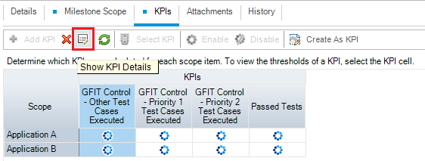

As you can see in this optional configuration example I am filtering the generic KPI to look only at unit tests.

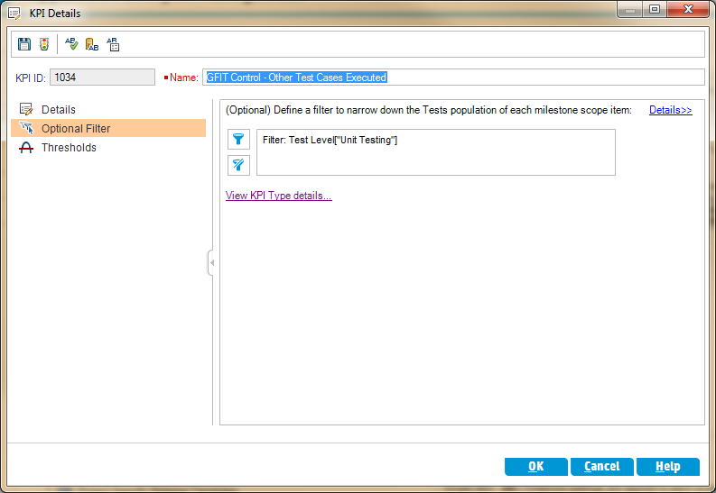

## GFIT Control – Priority 1 test cases executed

This KPI is optionally filtered to look only at UNIT test cases.

### KPI type

This is a Percentage KPI. It is better when it is higher.

### Entities Measured

Filter: Execution Status[Passed Or Failed];Test Priority[1.Immediately]

Out of

Filter: Test Priority[1.Immediately]

### Fields required

* Test Case Priority.
* Execution Status
* Test Level

## GFIT Control – Priority 2 test cases executed

This KPI is optionally filtered to look only at UNIT test cases.

### KPI type

This is a Percentage KPI. It is better when it is higher.

### Entities Measured

Filter: Execution Status[Passed Or Failed];Test Priority[2.Urgent]

Out of

Filter: Test Priority[2.Urgent]

### Fields required

* Test Case Priority.
* Execution Status
* Test Level

## GFIT Control – Other test cases executed

This KPI is optionally filtered to look only at UNIT test cases.

### KPI type

This is a Percentage KPI. It is better when it is higher.

### Entities Measured

Filter: Execution Status[Passed Or Failed];Test Priority[3 or 4]

Out of

Filter: Test Priority[3 or 4]

### Fields required

* Test Case Priority.
* Execution Status
* Test Level

## GFIT Control – Passed Tests

### KPI type

This is a percentage KPI. It is better when its higher.

### Entities Measured

Filter: Execution Status[Passed]

Out of

All tests

### Fields required

* Test Execution Status
* Test Level

# Milestone System Test Execution Complete

## GFIT Control – Priority 1 test cases executed

This KPI is optionally filtered to look only at System test cases.

### KPI type

This is a Percentage KPI. It is better when it is higher.

### Entities Measured

Filter: Execution Status[Passed Or Failed];Test Priority[1.Immediately]

Out of

Filter: Test Priority[1.Immediately]

### Fields required

* Test Case Priority.
* Execution Status
* Test Level

## GFIT Control – Priority 2 test cases executed

This KPI is optionally filtered to look only at System test cases.

### KPI type

This is a Percentage KPI. It is better when it is higher.

### Entities Measured

Filter: Execution Status[Passed Or Failed];Test Priority[2.Urgent]

Out of

Filter: Test Priority[2.Urgent]

### Fields required

* Test Case Priority.
* Execution Status
* Test Level

## GFIT Control – Other test cases executed

This KPI is optionally filtered to look only at System test cases.

### KPI type

This is a Percentage KPI. It is better when it is higher.

### Entities Measured

Filter: Execution Status[Passed Or Failed];Test Priority[3 or 4]

Out of

Filter: Test Priority[3 or 4]

### Fields required

* Test Case Priority.
* Execution Status
* Test Level

## GFIT Control – Passed Tests

This KPI is optionally filtered to look at system test cases

### KPI type

This is a percentage KPI. It is better when its higher.

### Entities Measured

Filter: Execution Status[Passed]

Out of

All tests

### Fields required

* Test Execution Status
* Test Level

# Milestone UAT Execution Complete

## GFIT Control – Priority 1 test cases executed

This KPI is optionally filtered to look only at UAT test cases.

### KPI type

This is a Percentage KPI. It is better when it is higher.

### Entities Measured

Filter: Execution Status[Passed Or Failed];Test Priority[1.Immediately]

Out of

Filter: Test Priority[1.Immediately]

### Fields required

* Test Case Priority.
* Execution Status
* Test Level

## GFIT Control – Priority 2 test cases executed

This KPI is optionally filtered to look only at UAT test cases.

### KPI type

This is a Percentage KPI. It is better when it is higher.

### Entities Measured

Filter: Execution Status[Passed Or Failed];Test Priority[2.Urgent]

Out of

Filter: Test Priority[2.Urgent]

### Fields required

* Test Case Priority.
* Execution Status
* Test Level

## GFIT Control – Other test cases executed

This KPI is optionally filtered to look only at UAT test cases.

### KPI type

This is a Percentage KPI. It is better when it is higher.

### Entities Measured

Filter: Execution Status[Passed Or Failed];Test Priority[3 or 4]

Out of

Filter: Test Priority[3 or 4]

### Fields required

* Test Case Priority.
* Execution Status
* Test Level

## GFIT Control – Passed Tests

This KPI is optionally filtered to look at UAT test cases

### KPI type

This is a percentage KPI. It is better when its higher.

### Entities Measured

Filter: Execution Status[Passed]

Out of

All tests

### Fields required

* Test Execution Status
* Test Level

# Milestone Code is defect free

This milestone tracks the status of defects across the whole project.

## GFIT Control – Critical Defects

## KPI Type

This is a numerical KPI. It is better when lower. Obviously!

## Entities Measured

Defects of type critical

## Required Fields

* Defect severity

## GFIT Control – Major Defects

## KPI Type

This is a numerical KPI. It is better when lower.

## Entities Measured

Defects of type Major

## Required Fields

* Defect severity

## GFIT Control – Average Defects

## KPI Type

This is a numerical KPI. It is better when lower.

## Entities Measured

Defects of type Average

## Required Fields

* Defect severity

# ALM Screens this information comes from

These are the screens in ALM where you can see the KPI details. There is nothing in this document that you cannot get directly from ALM in these screens and in fact this whole document is simply these screens typed out in long format.

